MSI Limited-Edition Stealth 16 Mercedes-AMG Motorsport is Now Ready to Pre-Order

Dubai, UAE,19 August 2023: MSI, the world-leading laptop brand, proudly unveiled its latest limited-edition laptop, the Stealth 16 Mercedes-AMG Motorsport. It seamlessly combines luxurious design with extreme performance, promising a luxury gaming experience. The pre-orders of the limited edition is available at Virgin Megastore, with a starting price of AED 12,999.

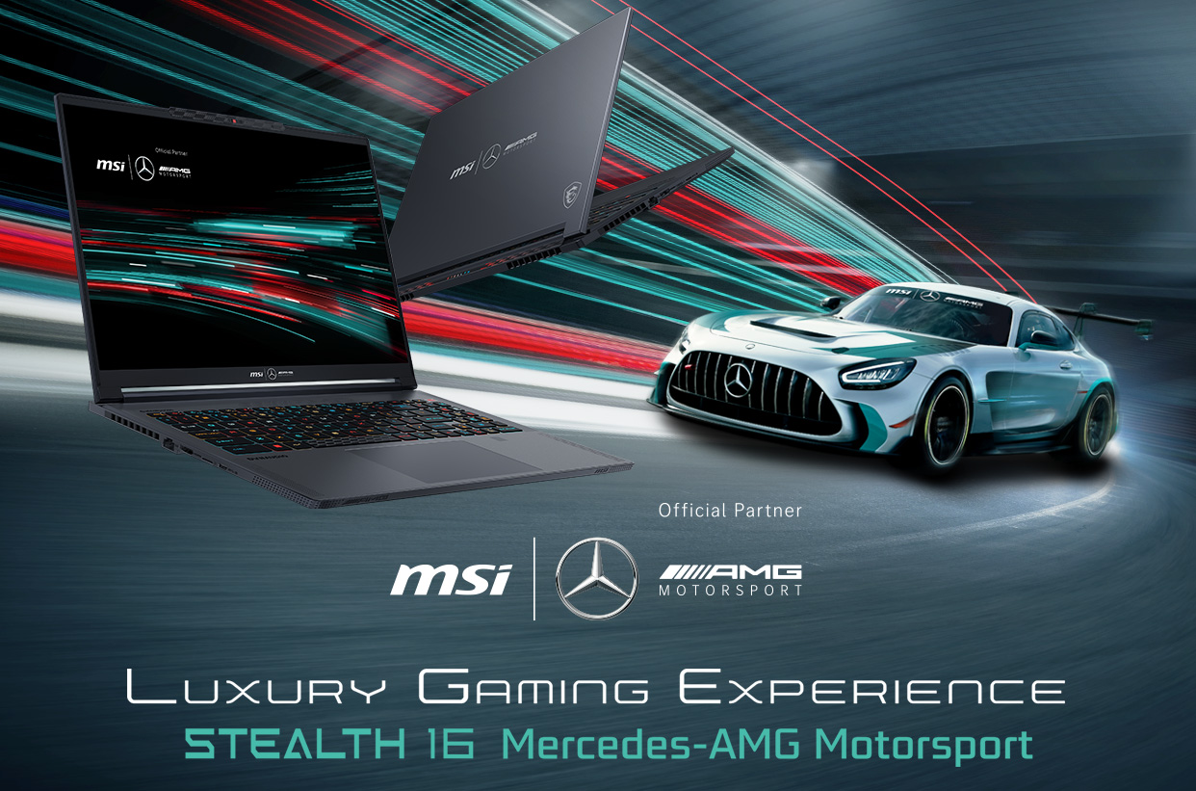

Experience the legacy of luxury and speed. The latest Stealth 16 Mercedes-AMG Motorsport laptop boasts an exquisite Selenite Grey aesthetic design, featuring the exclusive AMG Rhombuses pattern and a chassis crafted with magnesium-aluminum alloy. This low-key co-branded design exemplifies the craftsmanship and elegance that epitomizes the synergy between Mercedes-AMG and MSI.

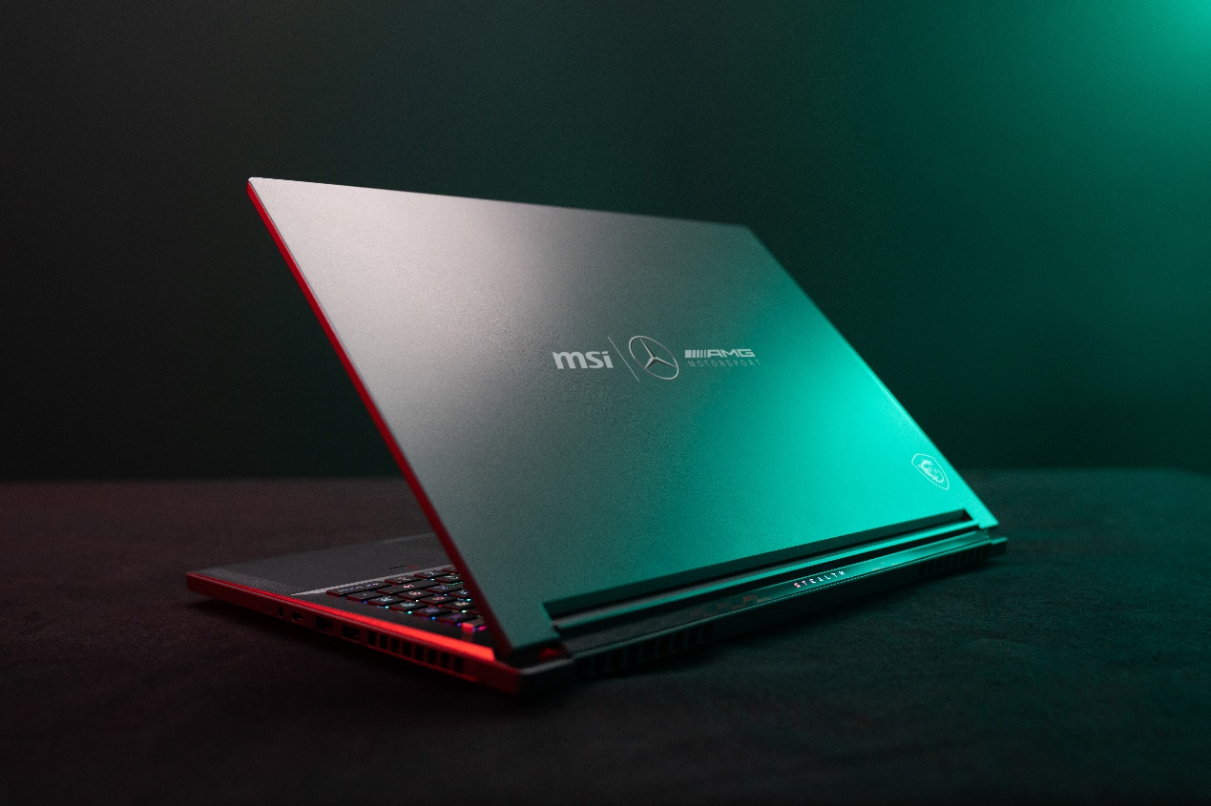

In addition to its aesthetic design, the limited-edition model offers extreme performance, boasting the cutting-edge 13th Gen Intel® Core™ i9 processor paired with NVIDIA® GeForce RTX™ 40 Series Laptop GPUs. The Stealth 16 Mercedes-AMG Motorsport also features a stunning 16:10 4K OLED panel, delivering exceptional contrast and vibrant colors that create an immersive and captivating gaming experience.

The Stealth 16 Mercedes-AMG Motorsport offers an exclusive package comprising a designed color box, a mouse, a mouse pad, a USB drive, an elegant pouch, a collection of postcards, and a cable tie, all precisely curated to enhance the luxurious experience shared by both MSI and Mercedes-AMG.
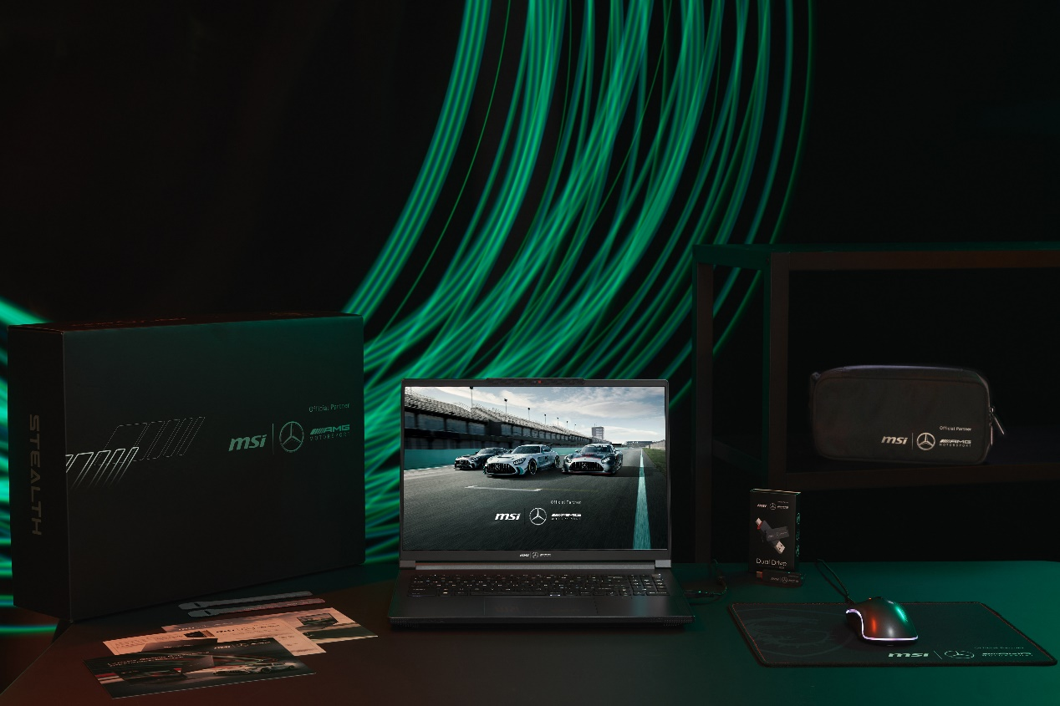
Seize the opportunity to indulge in the luxury gaming experience with the newest co-branded Stealth 16 Mercedes-AMG Motorsport. Secure your order now at the pre-order link: https://msi.gm/S7714561

For high-res images, please visit: https://msi.gm/S489AB73

